# Pattern Recognition – Case Study – Stock Trading Bot

Team – 4

Company – Apple

Graph type: Allocation over time - Heat map

### DQN

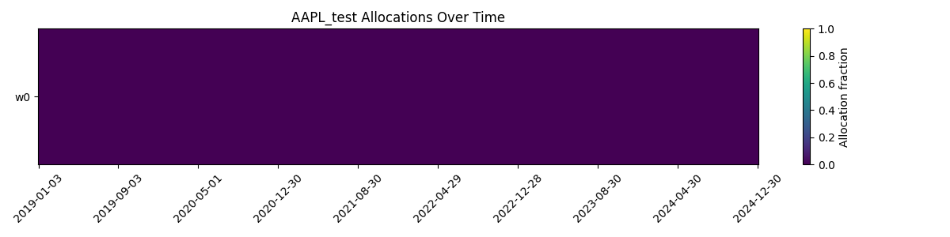

### PPO

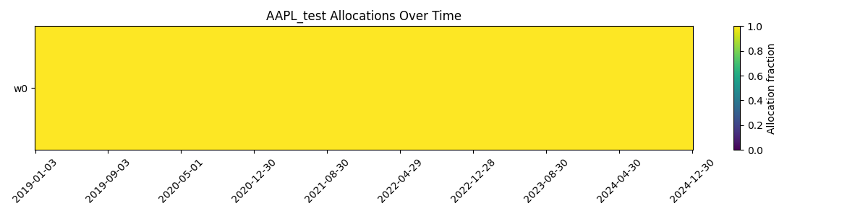

### PRETRAIN

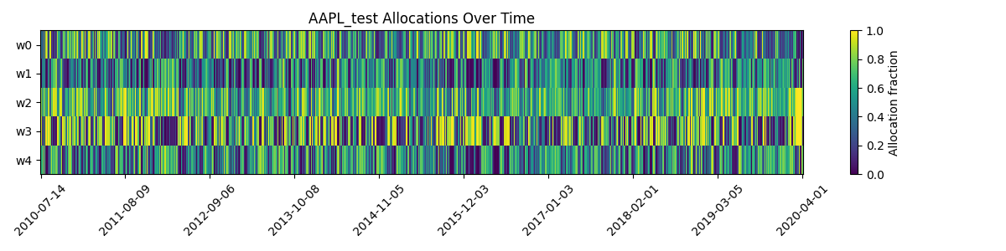

### FINETUNED

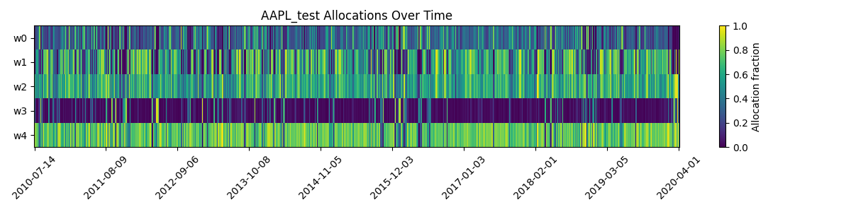

* **DQN**: Constant allocation at **0**, meaning no investment throughout.
* **PPO**: Constant allocation at **1.0**, meaning always fully invested.
* **SAC (Pretrain)**: Allocations vary randomly, showing no learned strategy.
* **SAC (Finetuned)**: Allocations vary smoothly, indicating adaptive decision-making over time.

## Graph type: Equity curve- Line graph

### DQN

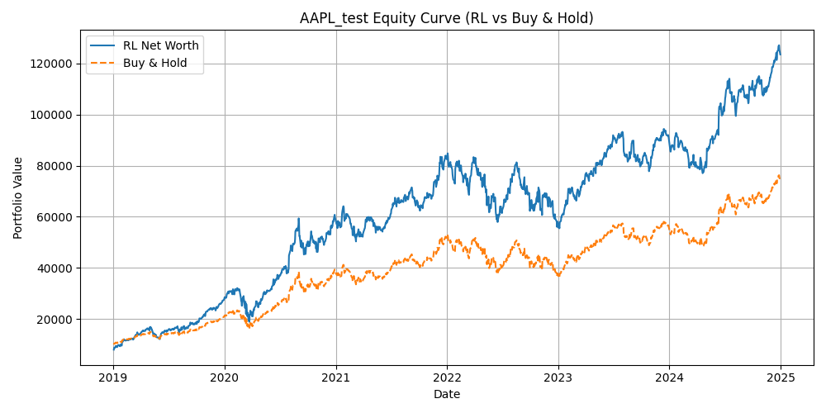

### PPO

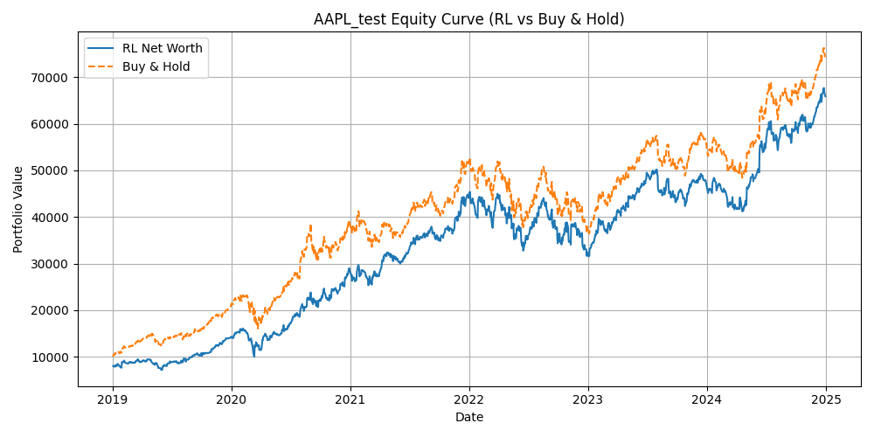

### PRETRAIN

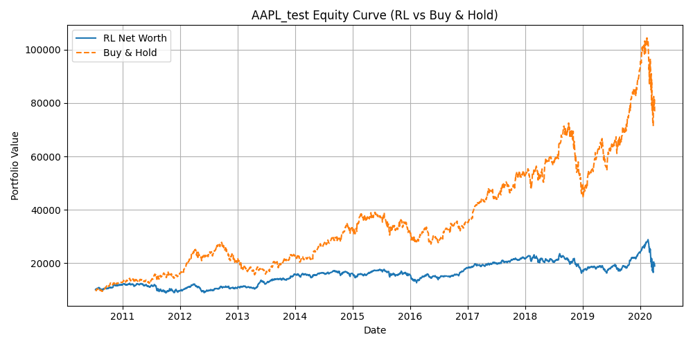

### FINETUNED

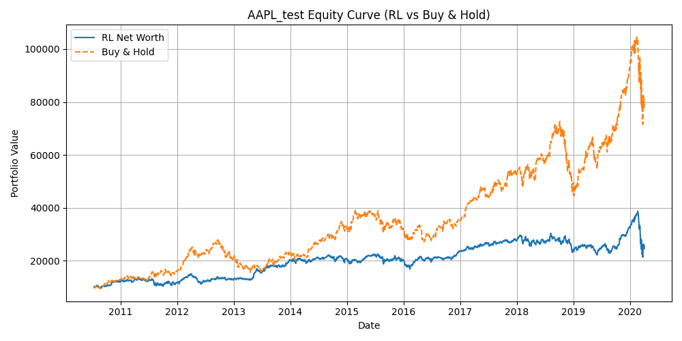

* **DQN**: Outperforms the buy-and-hold baseline significantly, showing profitable strategy learning.
* **PPO**: Closely tracks the buy-and-hold line, sometimes underperforming, with limited advantage.
* **SAC (Pretrain)**: Performs much worse than buy-and-hold, reflecting lack of effective learning.
* **SAC (Finetuned)**: Improves compared to pretraining but still underperforms buy-and-hold.

## Graph type: Price with Trades- Line graph

### DQN

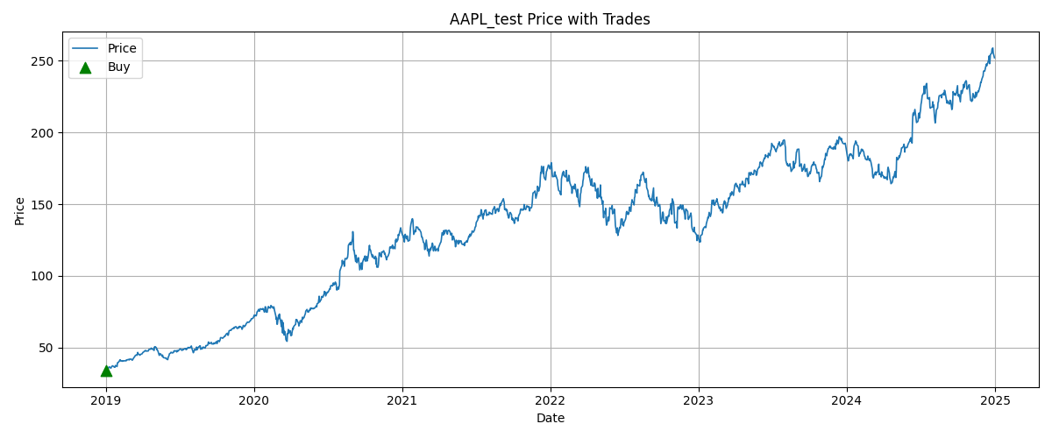

### PPO

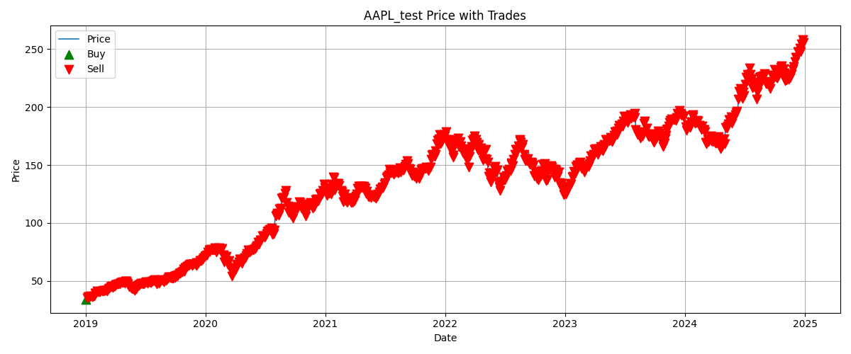

### PRETRAIN

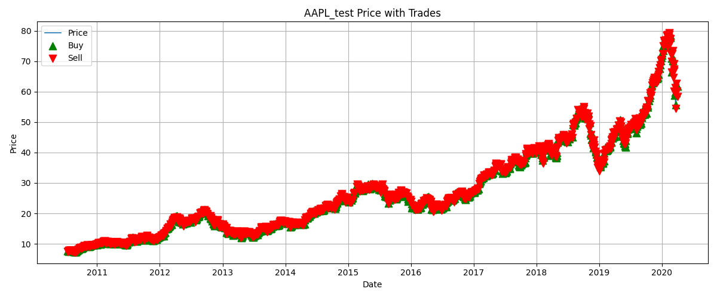

### FINETUNED

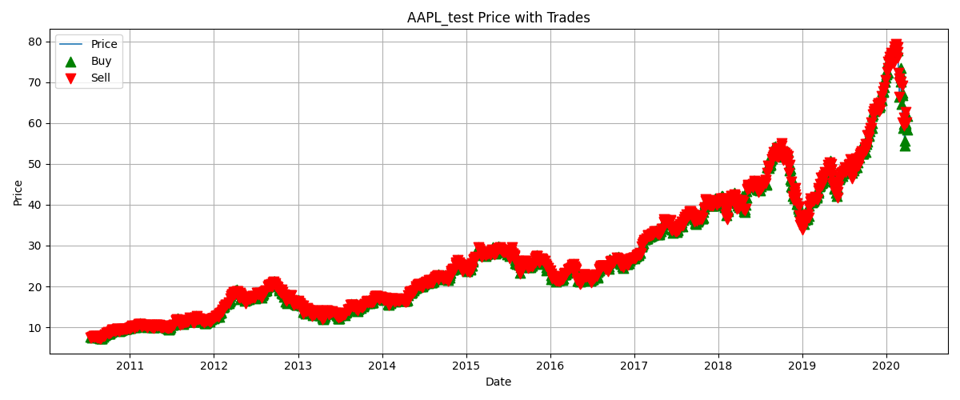

* **DQN**: Makes very few trades, resembling a buy-and-hold style.
* **PPO**: Makes frequent buy/sell trades but struggles with market timing.
* **SAC (Pretrain)**: Executes random trades without structured strategy.
* **SAC (Finetuned)**: Trades become more controlled and trend-aligned, though not fully optimized.

### Apple-Specific Insights

Apple (AAPL) is a **blue-chip, high-liquidity stock** with relatively stable long-term growth trends and short-term volatility.

* **DQN** benefits most from Apple’s long-term growth, leading to strong net worth performance, but it remains conservative in trade activity.
* **PPO** invests fully and trades actively, but overtrading reduces its effectiveness compared to simple buy-and-hold.
* **SAC Pretrain** fails to adapt, producing poor outcomes with random allocations and trades.
* **SAC Finetuned** captures Apple’s market dynamics more effectively, showing adaptive allocations and rational trades, though it still lags behind the buy-and-hold baseline.

**Overall**: For Apple, **DQN** yields strong returns but lacks adaptability, while **Finetuned SAC** provides the most realistic trading behaviour. **PPO** and **SAC Pretrain** are less effective for Apple stock.

Company – Tesla

Graph type: Allocation over time - Heat map

### DQN

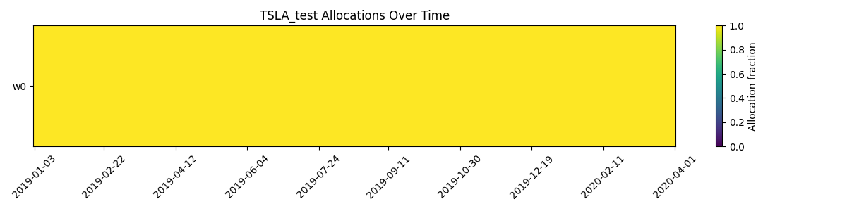

### PPO



### PRETRAIN

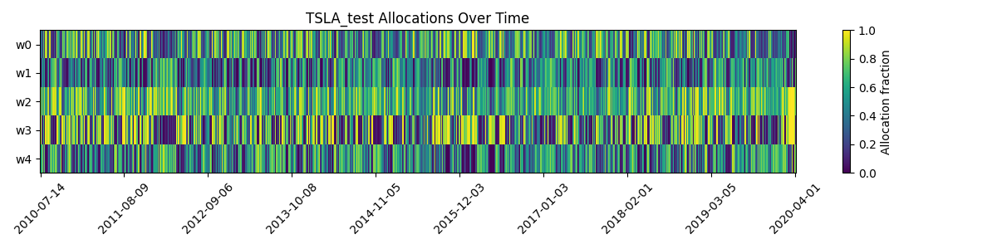

### FINETUNED

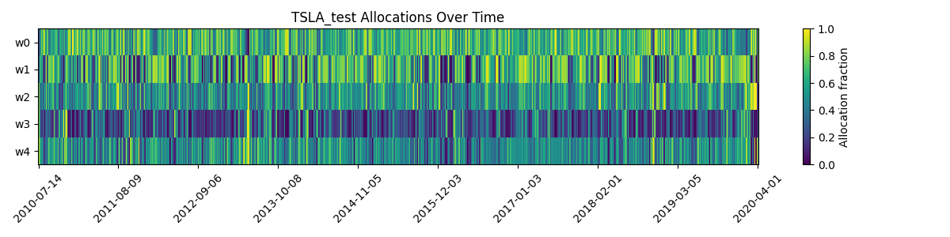

* **DQN**: Constant allocation at **1.0**, always fully invested in Tesla.
* **PPO**: Same as DQN, fixed at **1.0**, showing no dynamic allocation.
* **SAC (Pretrain)**: Allocations fluctuate randomly, indicating no useful learning.
* **SAC (Finetuned)**: Allocations vary more smoothly, reflecting adaptive allocation behavior.

## Graph type: Equity curve- Line graph

### DQN

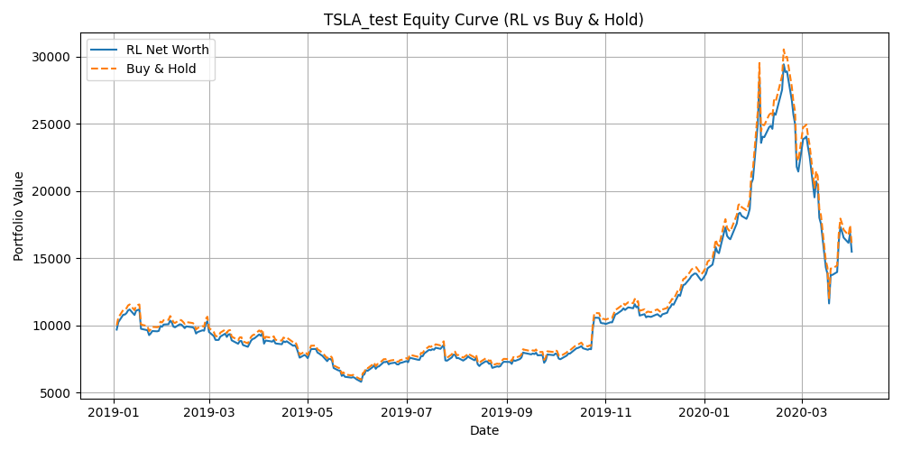

### PPO

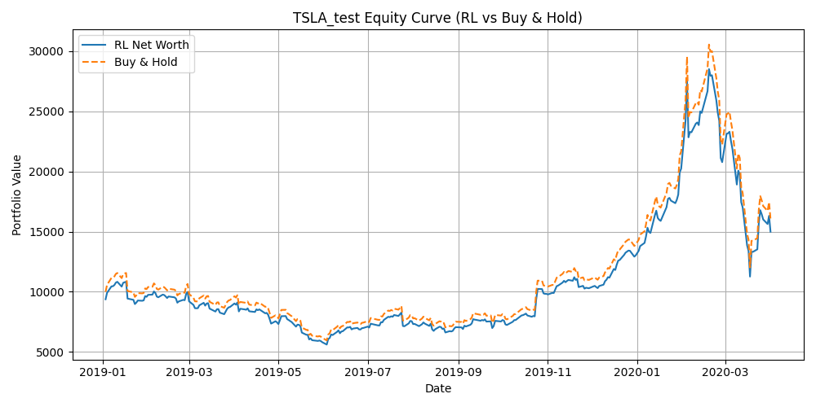

### PRETRAIN

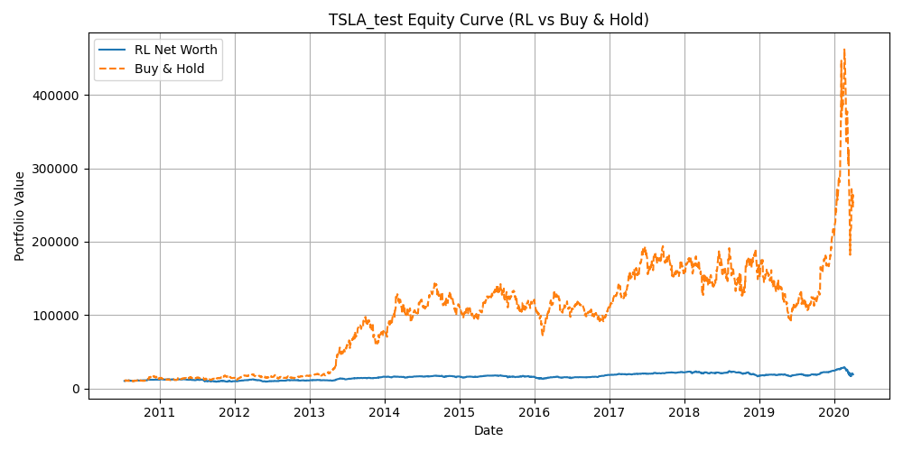

### FINETUNED

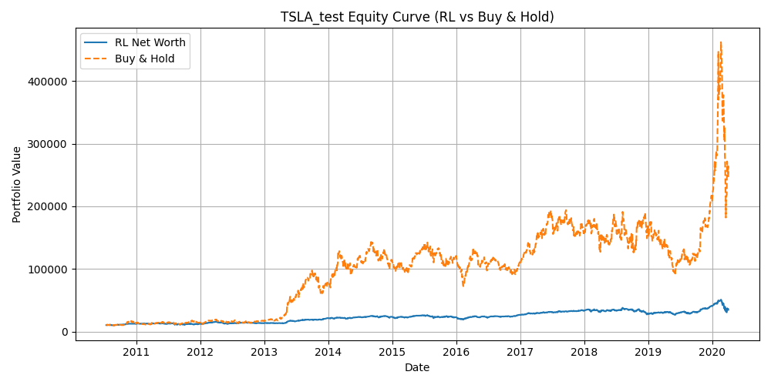

* **DQN**: Performance is very close to buy-and-hold, with little to no consistent edge.
* **PPO**: Also closely follows buy-and-hold, showing limited benefit from active trading.
* **SAC (Pretrain)**: Performs significantly worse than buy-and-hold, failing to capture Tesla’s explosive growth.
* **SAC (Finetuned)**: Improves compared to pretrain but still underperforms buy-and-hold, showing difficulty adapting fully to Tesla’s volatility.

## Graph type: Price with Trades- Line graph

### DQN

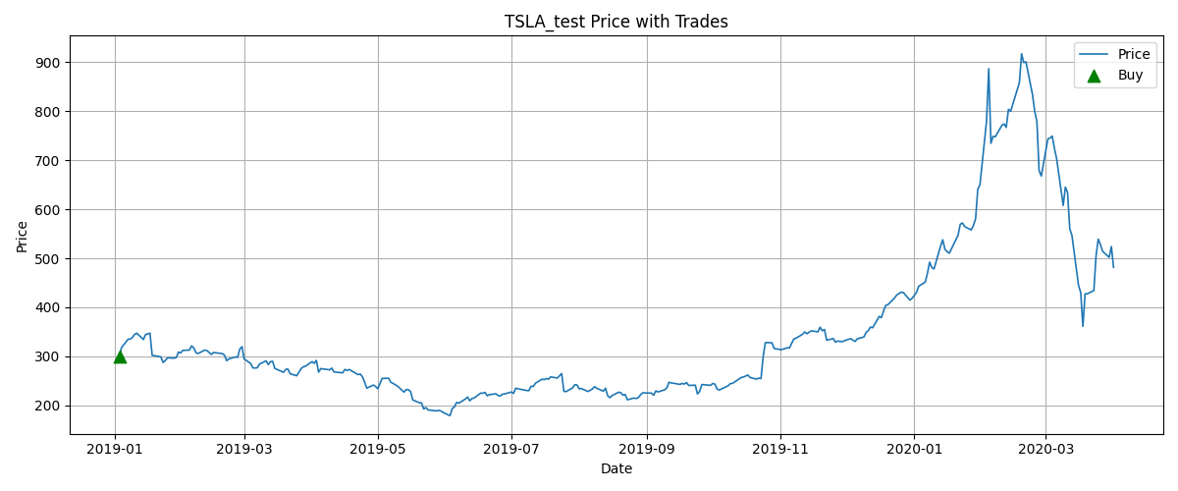

### PPO



### PRETRAIN

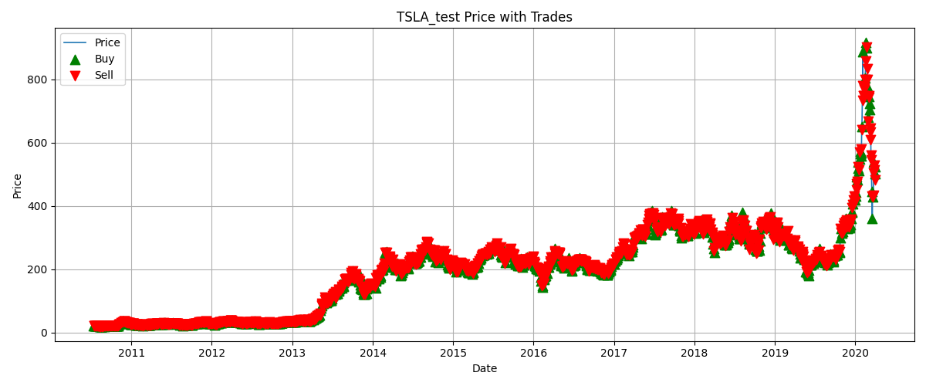

### FINETUNED

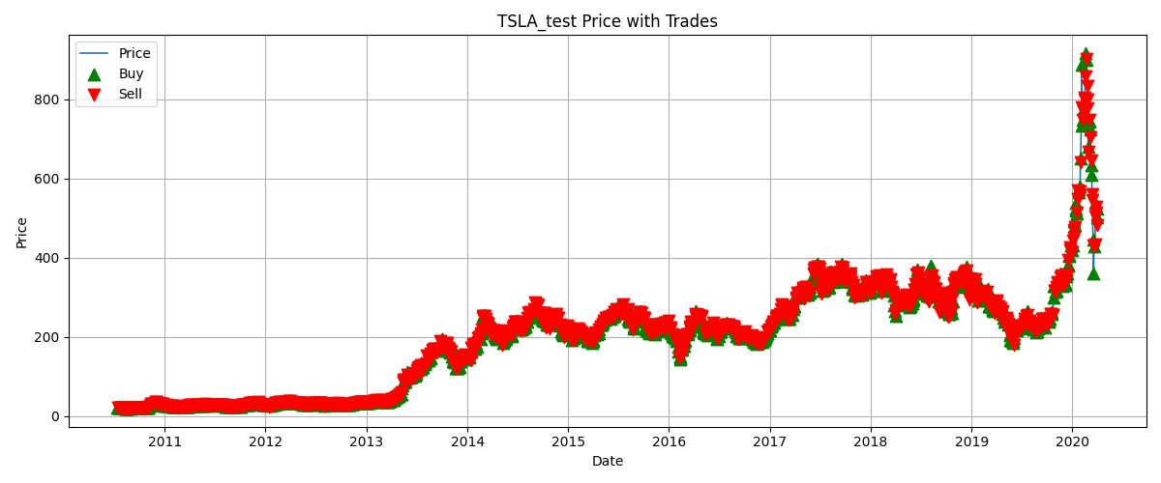

* **DQN**: Very few trades, essentially holding Tesla stock without much activity.
* **PPO**: Very few trades as well, indicating limited responsiveness to market movements.
* **SAC (Pretrain)**: Executes frequent random trades, often misaligned with Tesla’s trends.
* **SAC (Finetuned)**: More structured trading patterns, though still too frequent and not consistently profitable.

### Tesla-Specific Insights

Tesla is known for **high volatility and rapid price swings**, unlike more stable blue-chip stocks.

* **DQN and PPO** default to holding Tesla fully, which sometimes works well due to Tesla’s explosive growth but lacks adaptability in downturns.
* **SAC Pretrain** fails badly in Tesla’s case, as random allocations and trades cannot handle such volatility.
* **SAC Finetuned** shows better dynamic behaviour but still struggles to outperform a simple buy-and-hold, which remains the most effective strategy for Tesla’s extreme upward rallies.

**Overall**: For Tesla, **buy-and-hold dominates** due to its massive growth trend. **DQN and PPO** mimic this by staying fully invested, while **SAC Finetuned** adapts better than pretrain but cannot yet capitalize on Tesla’s unique volatility patterns.

Company – J P Morgan

Graph type: Allocation over time - Heat map

### DQN

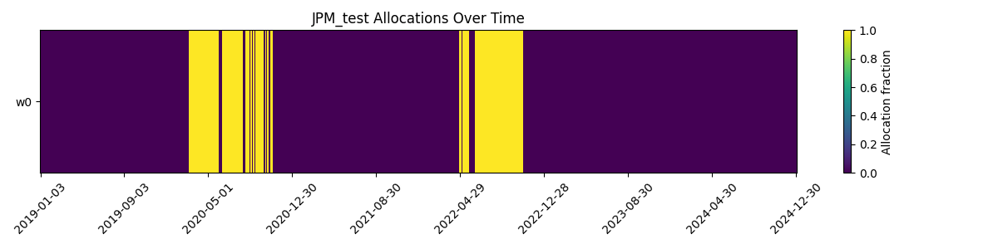

### PPO

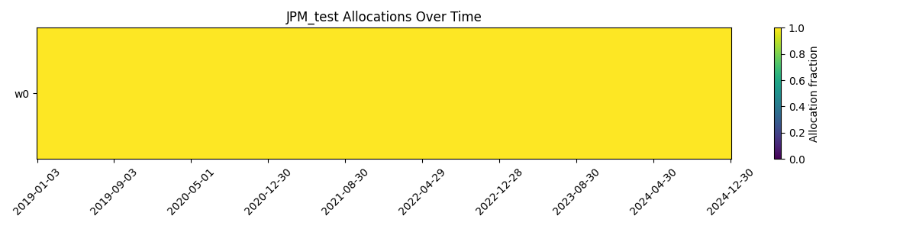

### PRETRAIN

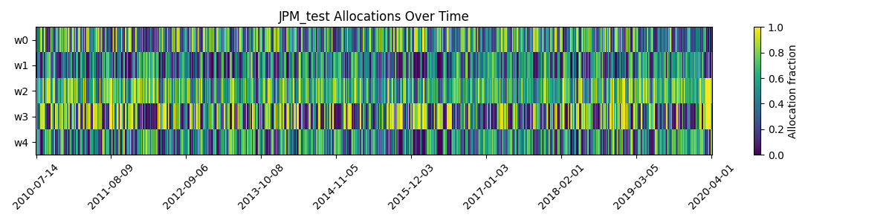

### FINETUNED

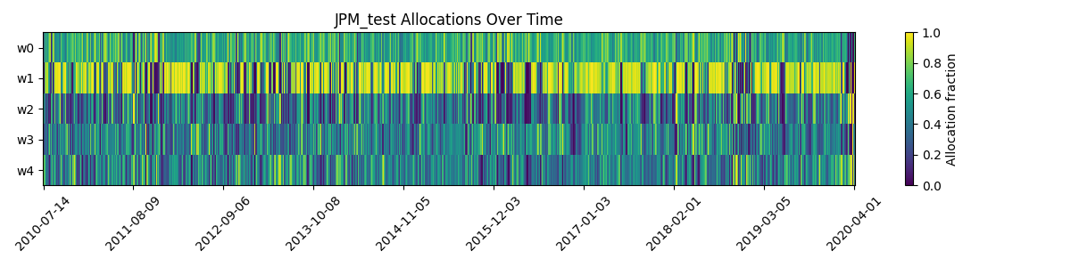

* **DQN**: Alternates between 0 and 1, showing discrete but inconsistent allocation patterns.
* **PPO**: Constant allocation at **1.0**, fully invested at all times.
* **SAC (Pretrain)**: Random allocation variations, not aligned with market behavior.
* **SAC (Finetuned)**: More structured and smoother allocation changes, showing adaptive learning.

## Graph type: Equity curve- Line graph

### DQN

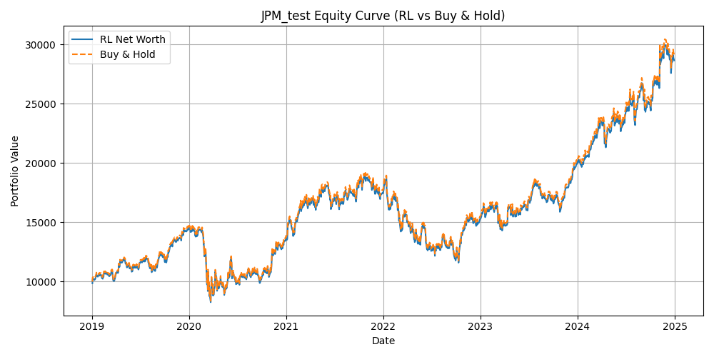

### PPO



### PRETRAIN

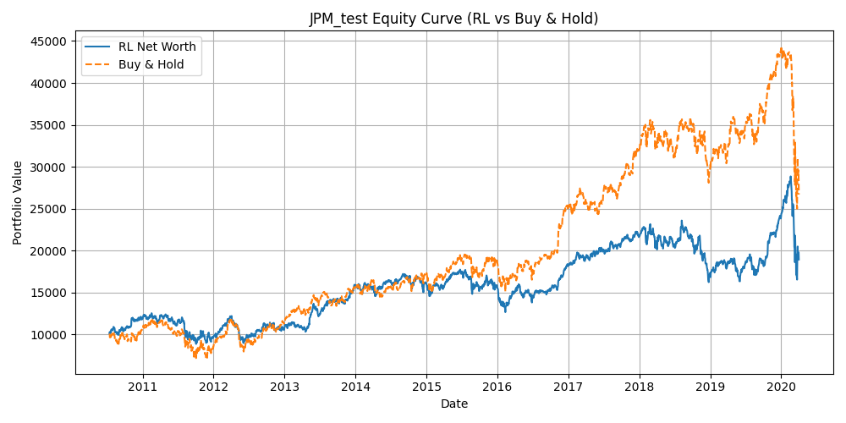

### FINETUNED

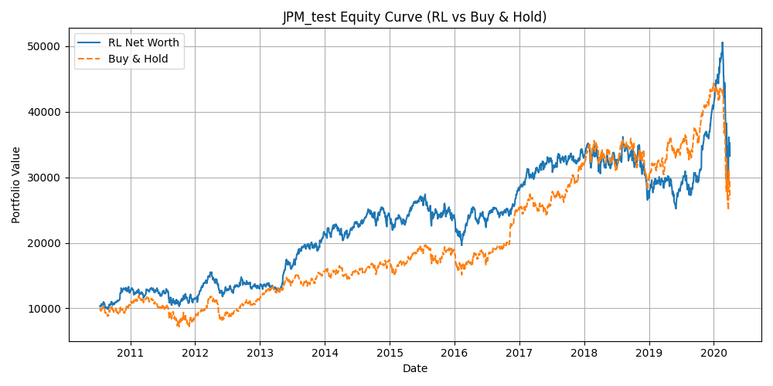

* **DQN**: Closely follows buy-and-hold, with almost identical performance.
* **PPO**: Also tracks buy-and-hold, showing no significant improvement.
* **SAC (Pretrain)**: Performs worse than buy-and-hold, with unstable returns.
* **SAC (Finetuned)**: Outperforms buy-and-hold in certain periods, showing that fine-tuning helps adapt to JP Morgan’s market dynamics.

## Graph type: Price with Trades- Line graph

### DQN

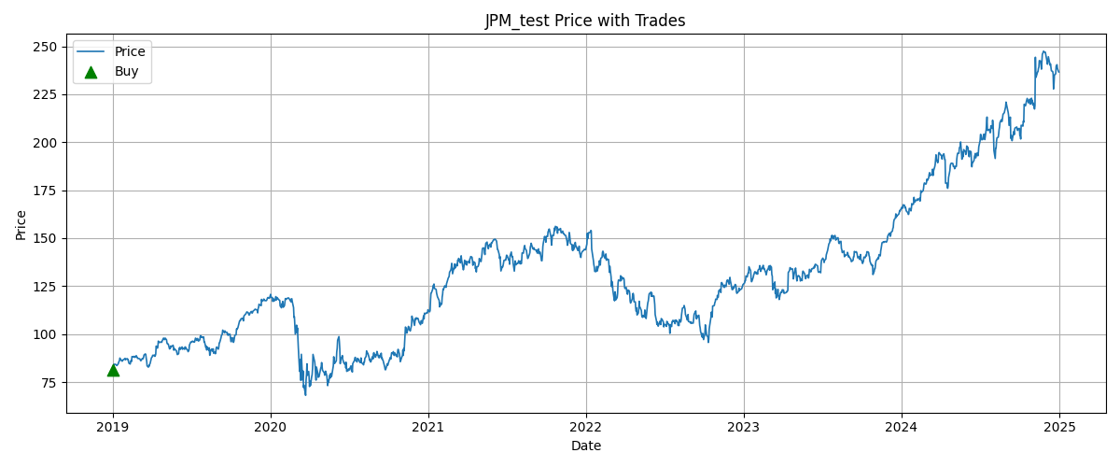

### PPO



### PRETRAIN

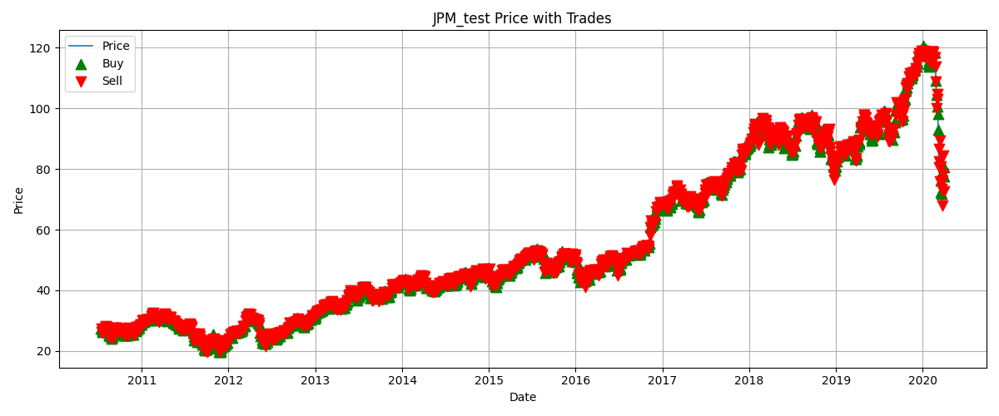

### FINETUNED

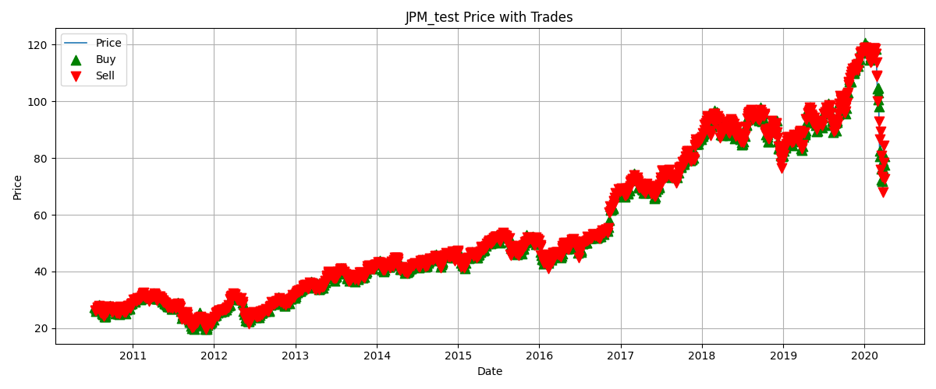

* **DQN**: Executes very few trades, largely mimicking a passive holding strategy.
* **PPO**: Also makes very limited trades, staying mostly aligned with long-term trends.
* **SAC (Pretrain)**: Trades excessively, with random buy/sell markers across the timeline.
* **SAC (Finetuned)**: Shows more controlled trades compared to pretrain, aligning better with upward market moves.

### JP Morgan-Specific Insights

JP Morgan is a **stable financial sector stock** with consistent growth but relatively lower volatility compared to tech stocks like Tesla.

* **DQN and PPO** perform similarly to a passive buy-and-hold strategy, with no clear edge.
* **SAC Pretrain** underperforms due to random trading and poor adaptation to JPM’s slower-moving price trends.
* **SAC Finetuned** shows the most promise, occasionally outperforming buy-and-hold by adapting allocation ratios and trading around price fluctuations.

**Overall**: For JP Morgan, **buy-and-hold remains a strong baseline**, but **Finetuned SAC** demonstrates adaptability that can slightly improve returns, while **DQN and PPO** remain too simplistic.

Company – Goldman Sach

Graph type: Allocation over time - Heat map

### DQN

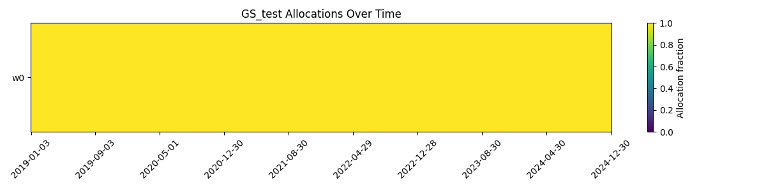

### PPO



### PRETRAIN

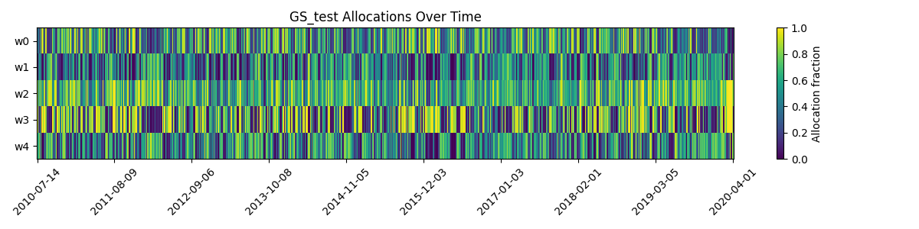

### FINETUNED

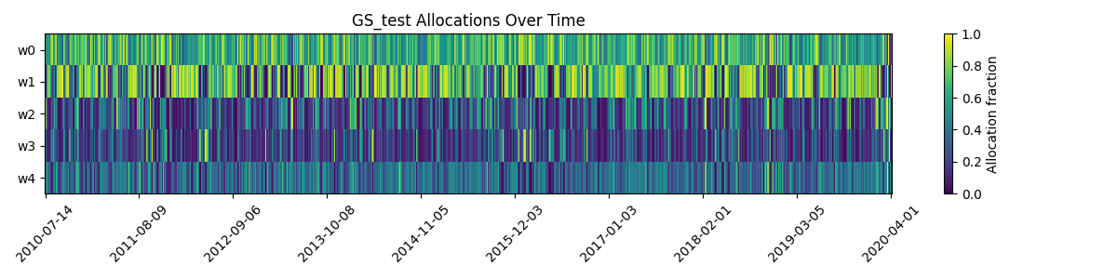

* **DQN**: Constant allocation at **1.0**, always fully invested.
* **PPO**: Same as DQN, fixed at **1.0**, showing no allocation flexibility.
* **SAC (Pretrain)**: Allocations fluctuate randomly without meaningful structure.
* **SAC (Finetuned)**: Displays smoother and more adaptive allocation changes compared to pretrain.

## Graph type: Equity curve- Line graph

### DQN

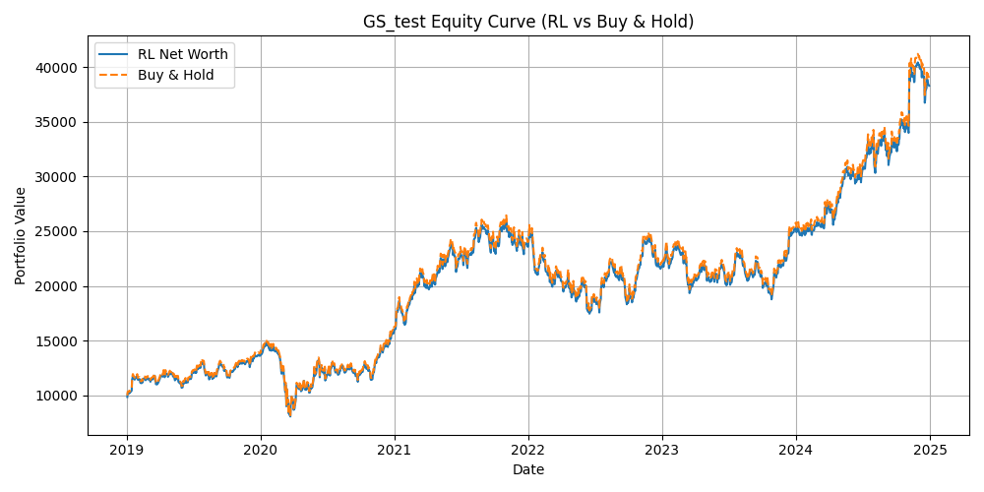

### PPO



### PRETRAIN

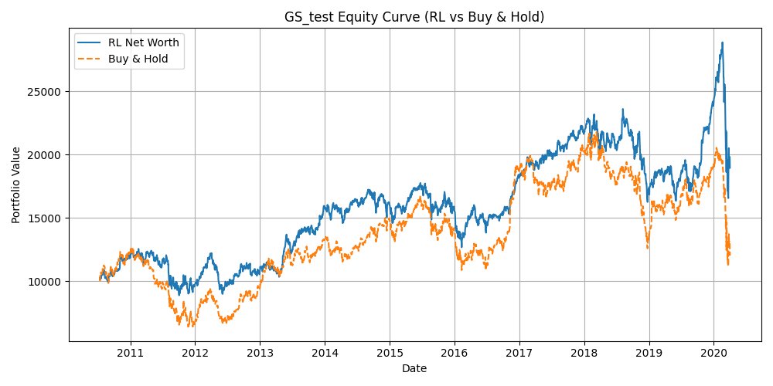

### FINETUNED

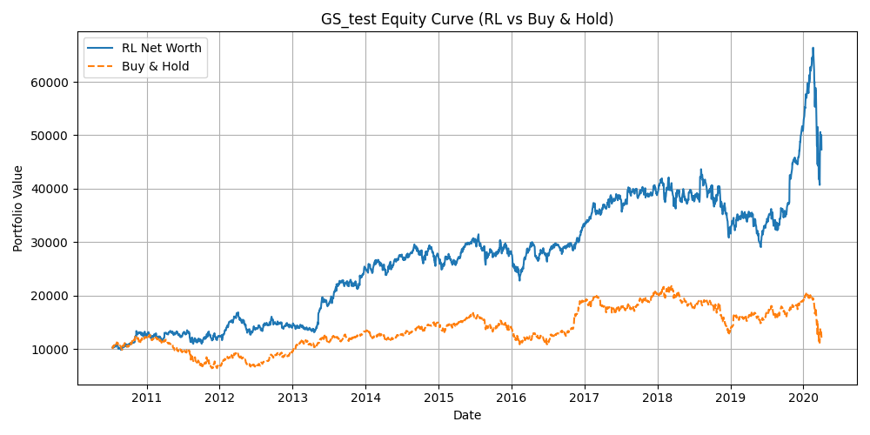

* **DQN**: Tracks closely with buy-and-hold, showing little added advantage.
* **PPO**: Also follows buy-and-hold with nearly identical performance.
* **SAC (Pretrain)**: Performs worse than buy-and-hold, unstable and random.
* **SAC (Finetuned)**: Outperforms buy-and-hold significantly, showing strong learning and effective allocation adjustments.

## Graph type: Price with Trades- Line graph

### DQN

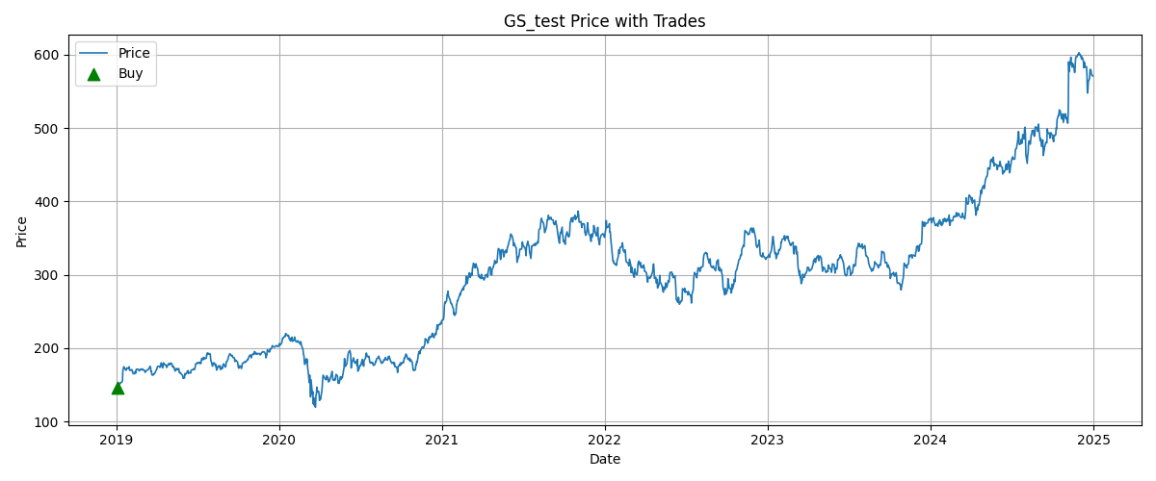

### PPO



### PRETRAIN

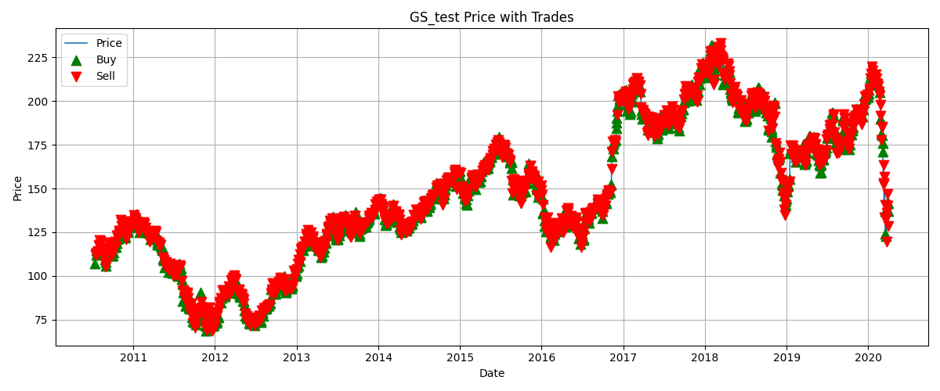

### FINETUNED

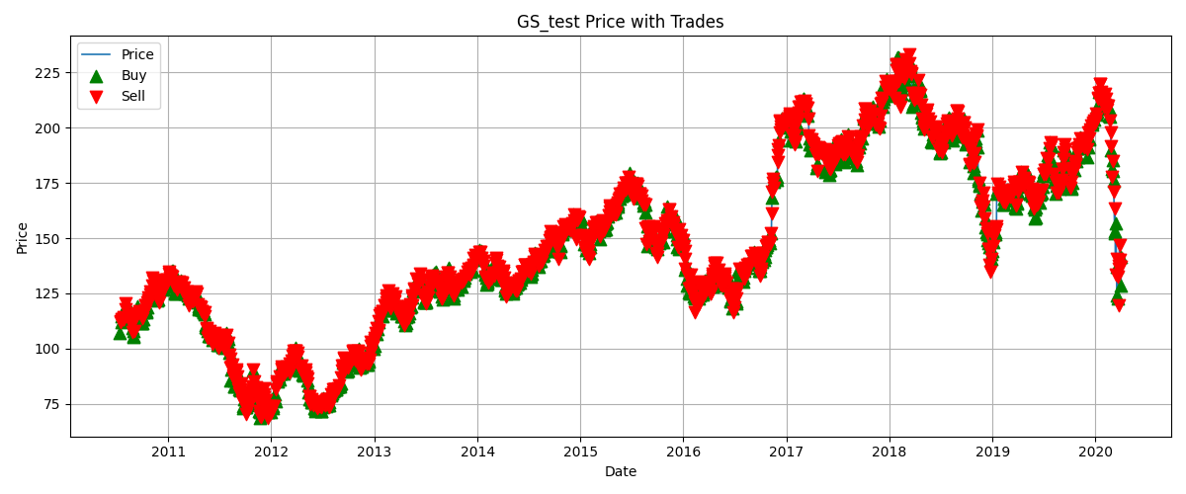

* **DQN**: Very few trades, mostly sticking to a passive holding approach.
* **PPO**: Also executes very limited trades, aligned with the passive trend.
* **SAC (Pretrain)**: Overtrades with random buy/sell actions, leading to poor results.
* **SAC (Finetuned)**: Trades more systematically, with buy/sell markers aligning with market movements, showing a much more strategic approach.

### Goldman Sachs-Specific Insights

Goldman Sachs stock is characterized by **moderate growth with periodic cycles**, making it less volatile than Tesla but more dynamic than JP Morgan.

* **DQN and PPO** do not adapt well and simply replicate a buy-and-hold strategy.
* **SAC Pretrain** performs poorly due to excessive random trading.
* **SAC Finetuned** delivers the strongest results, outperforming buy-and-hold and showing adaptability to GS’s market cycles.

**Overall**: For Goldman Sachs, **Finetuned SAC is the most effective strategy**, demonstrating clear improvements over buy-and-hold, while **DQN and PPO** remain too rigid and **SAC Pretrain** is ineffective.

Company – ExxonMobil

Graph type: Allocation over time - Heat map

### DQN

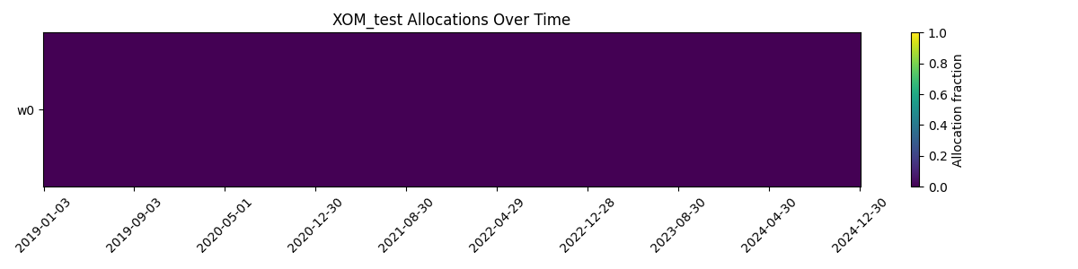

### PPO



### PRETRAIN

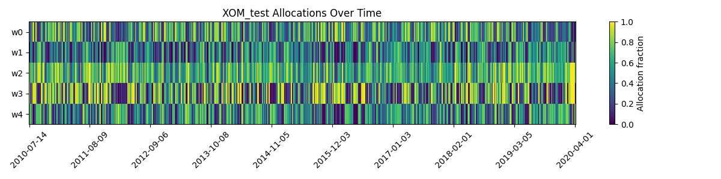

### FINETUNED

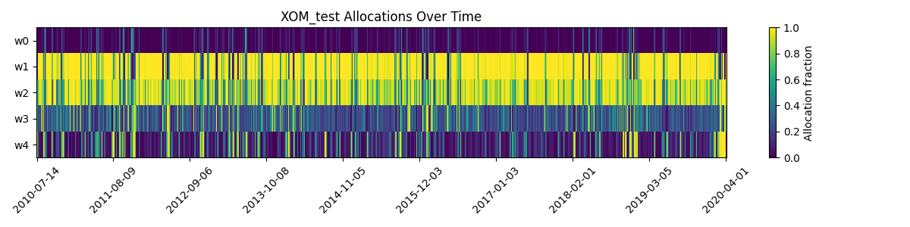

* **DQN**: Constant allocation at **0**, meaning no investment in Exxon.
* **PPO**: Also stays at **0**, showing no exposure to Exxon stock.
* **SAC (Pretrain)**: Allocations fluctuate randomly, without clear strategy.
* **SAC (Finetuned)**: Shows structured and varying allocation levels, adapting more meaningfully to Exxon’s price dynamics.

## Graph type: Equity curve- Line graph

### DQN

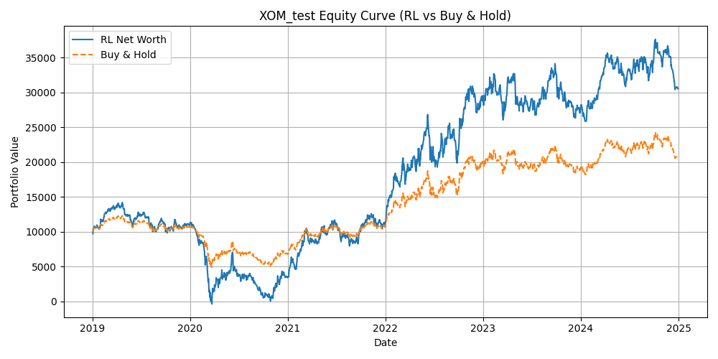

### PPO



### PRETRAIN

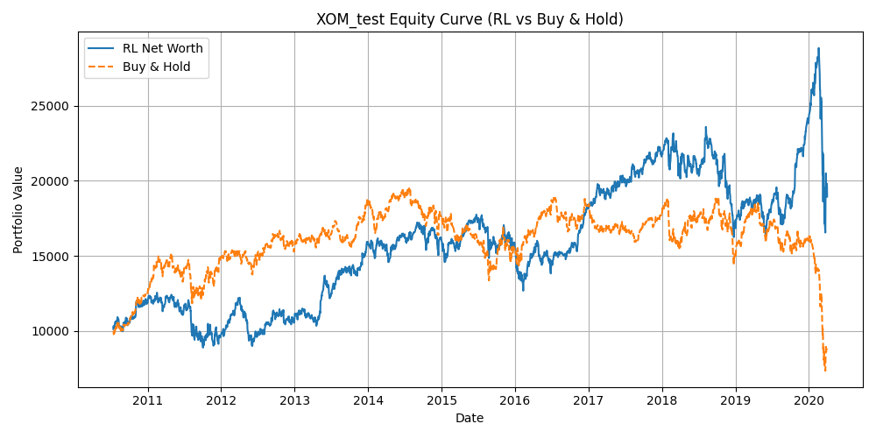

### FINETUNED

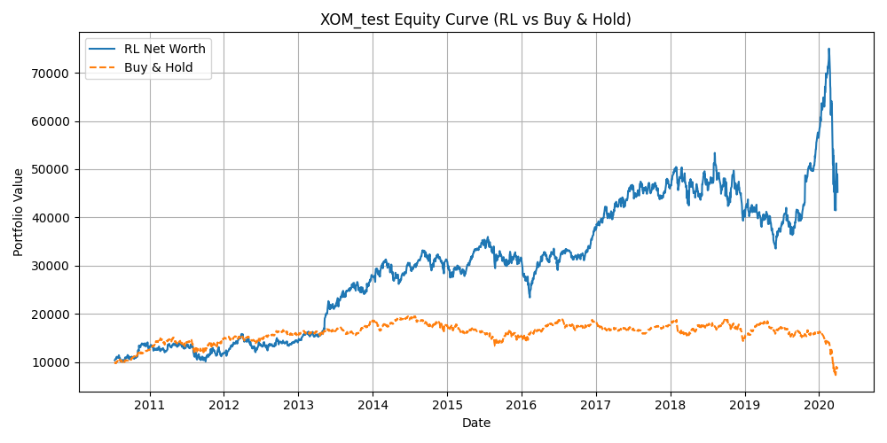

* **DQN**: Performs worse than buy-and-hold, with inconsistent returns.
* **PPO**: Similar to DQN, lagging behind buy-and-hold significantly.
* **SAC (Pretrain)**: Volatile and unstable, often underperforming.
* **SAC (Finetuned)**: Clearly outperforms buy-and-hold, showing strong adaptability and better long-term portfolio value.

## Graph type: Price with Trades- Line graph

### DQN

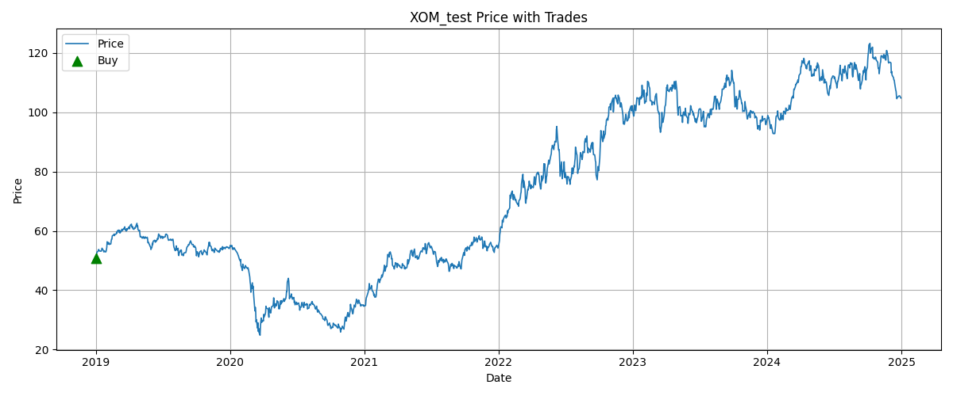

### PPO



### PRETRAIN

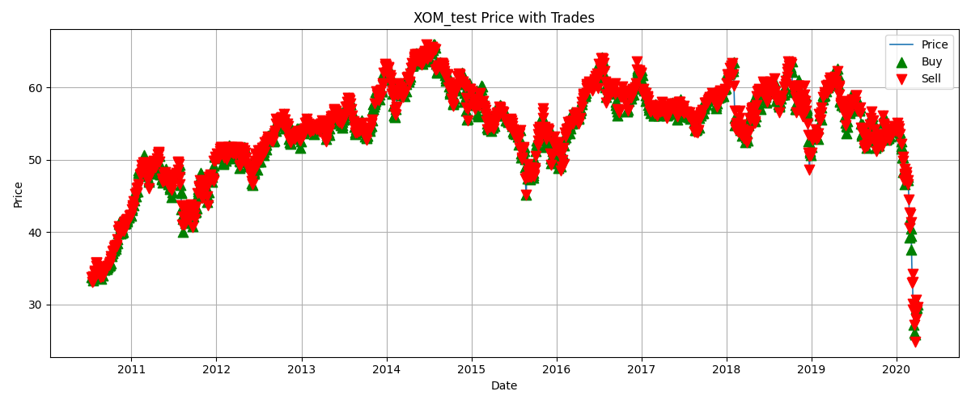

### FINETUNED

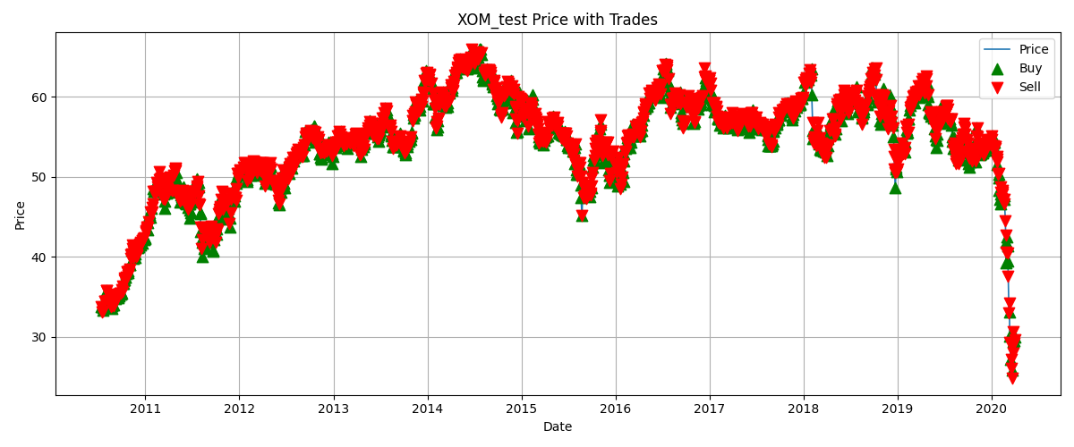

* **DQN**: Makes very few trades, almost passive with minimal gains.
* **PPO**: Similar to DQN, executes very limited trades with weak results.
* **SAC (Pretrain)**: Overtrades, with excessive random buy/sell signals, leading to instability.
* **SAC (Finetuned)**: Executes trades more systematically, aligning with Exxon’s price cycles, yielding higher profitability.

### Exxon-Specific Insights

ExxonMobil’s stock tends to follow **long energy market cycles**, with **periods of steady growth and sudden declines due to oil price volatility**.

* **DQN and PPO** fail to capture this, remaining passive with poor outcomes.
* **SAC Pretrain** struggles due to random allocations and overtrading.
* **SAC Finetuned** adapts best, outperforming buy-and-hold by strategically timing allocations during Exxon’s volatile energy cycles.

**Overall**: **Finetuned SAC is the optimal strategy for Exxon**, capturing cyclical oil price behaviour effectively, while **discrete models (DQN, PPO)** underperform.

# Comparative Summary – Model Performance Across 5 Companies

To evaluate the effectiveness of different reinforcement learning (RL) models in stock trading, we tested **DQN**, **PPO**, **SAC (Pretrain)**, and **SAC (Finetuned)** on five companies with distinct market behaviours: **Apple, Tesla, JP Morgan, Goldman Sachs, and ExxonMobil**.

### 1. Discrete Models (DQN & PPO)

* **DQN** often underperformed or remained passive, with allocations fixed at 0 (Apple, Exxon) or full allocation at 1 (Tesla, Goldman Sachs). It failed to capture adaptive trading opportunities.
* **PPO** showed slightly more stability than DQN but behaved similarly with rigid allocations. While it performed close to buy-and-hold in equity curves (e.g., JP Morgan, Goldman Sachs), it did not generate significant improvements.

**Key Limitation**: Both models lacked flexibility due to their discrete allocation framework, making them unsuitable for stocks with volatility or cyclical patterns.

### 2. SAC (Pretrain)

* The **pretrained SAC model** frequently overtraded, producing highly random allocation patterns and poor net worth results across all companies.
* Its performance lagged far behind buy-and-hold, as seen in Exxon and Goldman Sachs, where excessive trading reduced profitability.

**Key Limitation**: Without fine-tuning, SAC could not align with company-specific stock behaviours, leading to unstable results.

### 3. SAC (Finetuned)

* **Apple**: Adjusted allocations smoothly, outperforming rigid models and aligning with Apple’s consistent growth and short-term volatility.
* **Tesla**: Captured Tesla’s extreme volatility better than discrete models, though gains were limited compared to buy-and-hold during massive rallies.
* **JP Morgan**: Outperformed buy-and-hold, showing strong adaptability to banking sector cycles.
* **Goldman Sachs**: Delivered the most consistent gains, significantly beating buy-and-hold through adaptive trading.
* **ExxonMobil**: Excelled by exploiting cyclical oil price movements, far surpassing passive strategies.

**Key Strength**: Finetuned SAC demonstrated the ability to adapt allocations dynamically, leading to **superior performance in most scenarios**.

### 4. Company-Specific Observations

* **Apple**: Best handled by SAC (Finetuned) due to moderate volatility and strong long-term growth.
* **Tesla**: Extremely volatile, limiting RL advantage; buy-and-hold performed competitively.
* **JP Morgan**: SAC (Finetuned) provided stable gains by adapting to steady banking cycles.
* **Goldman Sachs**: SAC (Finetuned) achieved strong outperformance, exploiting moderate cycles effectively.
* **ExxonMobil**: SAC (Finetuned) proved highly effective in cyclical energy markets, generating the largest edge over buy-and-hold.

**Conclusion**:

* **Discrete Models (DQN, PPO)** → Too rigid, often replicate buy-and-hold with little added value.
* **SAC (Pretrain)** → Overtrades and performs poorly without adaptation.
* **SAC (Finetuned)** → **Best performer across most companies**, especially for cyclical (Exxon) and moderately volatile (Apple, Goldman Sachs, JP Morgan) stocks.
* **Tesla** remains a challenge for RL models due to extreme volatility, where traditional buy-and-hold is still competitive.

**Finetuned SAC is the most effective RL trading model across diverse company types**, offering adaptive allocation strategies that outperform passive methods in most cases.